Claude Watson School for the Arts
130 Doris Avenue, North York, Ontario M2N 0A8
Telephone: (416)-395-3180
E-mail: claudewatson@tdsb.on.ca
Victor Tran - Principal
130 Doris Avenue Toronto, Ontario M2N 0A8

Thank you to everyone for their patience, enthusiasm and hard work. It was wonderful to meet the students, hear and see their excitement on the return to school. As we continue with many new procedures, routines and learning, health and safety will be our primary focus.
Through my classroom visits and conversations with students in the yard, I was able to learn about their feelings and emotions being away from school and goals for this year. As I heard our students share their learning goals and challenges, I was impressed by their skills in creative thinking, problem solving and communication. This situation has tested their resilience and it was so inspiring to see their fortitude, strength and humour.
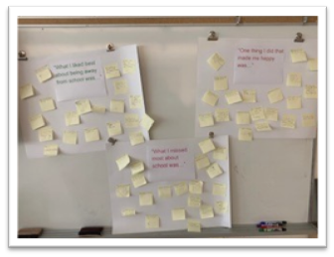

Here’s another marvelous example of our parents/guardians hard work in honouring our work to keep all students and staff safe. Thank you for dropping off your children and waiting outside the fence area. We are also grateful for families adjusting your timetable to pick up all students by 3:30 p.m.

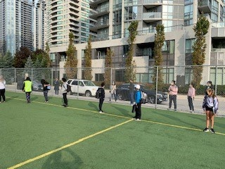

I look forward to working and learning with you through 2020/2021 school year.
Sincerely,
Victor Tran

